From Import Export

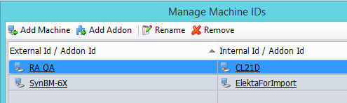

From External Beam Planning

